EXPERIMENT 5
Demonstrate transformation, scaling, binning, fixing skewed values and sampling.

AIM
To demonstrate data preprocessing techniques including feature engineering, Min-Max scaling, income binning, log transformation for skewed data, and random sampling on the California Housing dataset.

PROCEDURE
- Import pandas, numpy, matplotlib, MinMaxScaler, and fetch_california_housing.
- Load the California Housing dataset.
- Create a DataFrame with feature names.
- Take a sample of 1000 rows using sample().
- Create a new feature 'rooms_per_household' = AveRooms / HouseAge.
- Apply MinMaxScaler to normalize all features.
- Bin 'MedInc' into 5 income categories using pd.cut().
- Plot histogram of Population column to observe skewness.
- Apply log transformation using np.log1p().
- Plot histogram after log transformation.
- Draw a random sample of 5% of the full dataset.
- Print the shape of the random sample.

CODE

import pandas as pd
import numpy as np
import matplotlib.pyplot as plt
from sklearn.preprocessing import MinMaxScaler
from sklearn.datasets import fetch_california_housing
housing = fetch_california_housing()
data = pd.DataFrame(housing.data, columns=housing.feature_names)
sample_data = data.sample(n=1000, random_state=42)
# Feature Engineering
sample_data['rooms_per_household'] = (
sample_data['AveRooms'] / sample_data['HouseAge']
)
# Scaling
scaler = MinMaxScaler()
scaled_data = pd.DataFrame(
scaler.fit_transform(sample_data),
columns=sample_data.columns
)
# Binning
sample_data['income_bin'] = pd.cut(
sample_data['MedInc'],
bins=5,
labels=['Very Low','Low','Medium','High','Very High']
)
# Log Transformation (fixing skew)

plt.hist(sample_data['Population'], bins=30)
plt.title('Population Distribution (Skewed)')
plt.show()
sample_data['log_population'] = np.log1p(sample_data['Population'])
plt.hist(sample_data['log_population'], bins=30)
plt.title('Population Distribution After Log Transform')
plt.show()
# Random Sampling
random_sample = data.sample(frac=0.05, random_state=1)
print(random_sample.shape)

OUTPUT
Sample Shape: (1000, 8)
After Feature Engineering, Columns include: rooms_per_household Income Bins (head):
MedInc 1.6812 → Very Low MedInc 2.5313 → Very Low

Random Sample Shape: (1032, 8)
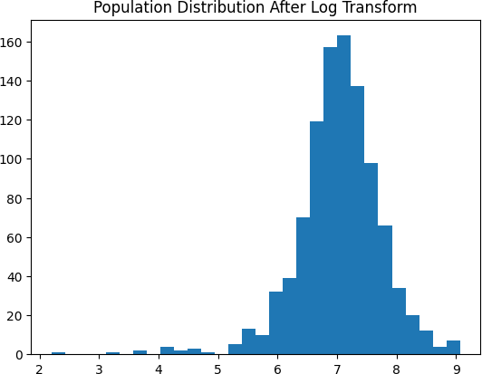
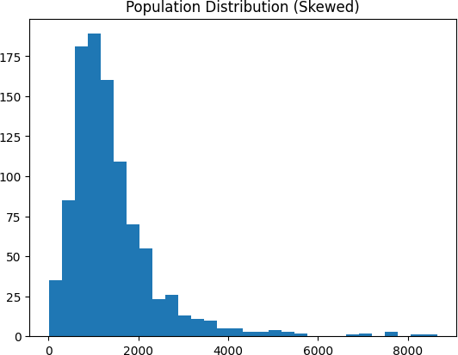

RESULT
Feature engineering, scaling, binning, and log transformation were successfully applied. The skewed population distribution was normalized using log1p transformation. MinMax scaling brought all features to [0, 1] range and random sampling extracted a 5% stratified sample.

